Sprint 1

|  |  |
| --- | --- |
| **Team id** | PNT2022TMID47056 |
| **Project name** | **Smart Fashion Recommender Application** |

Login page

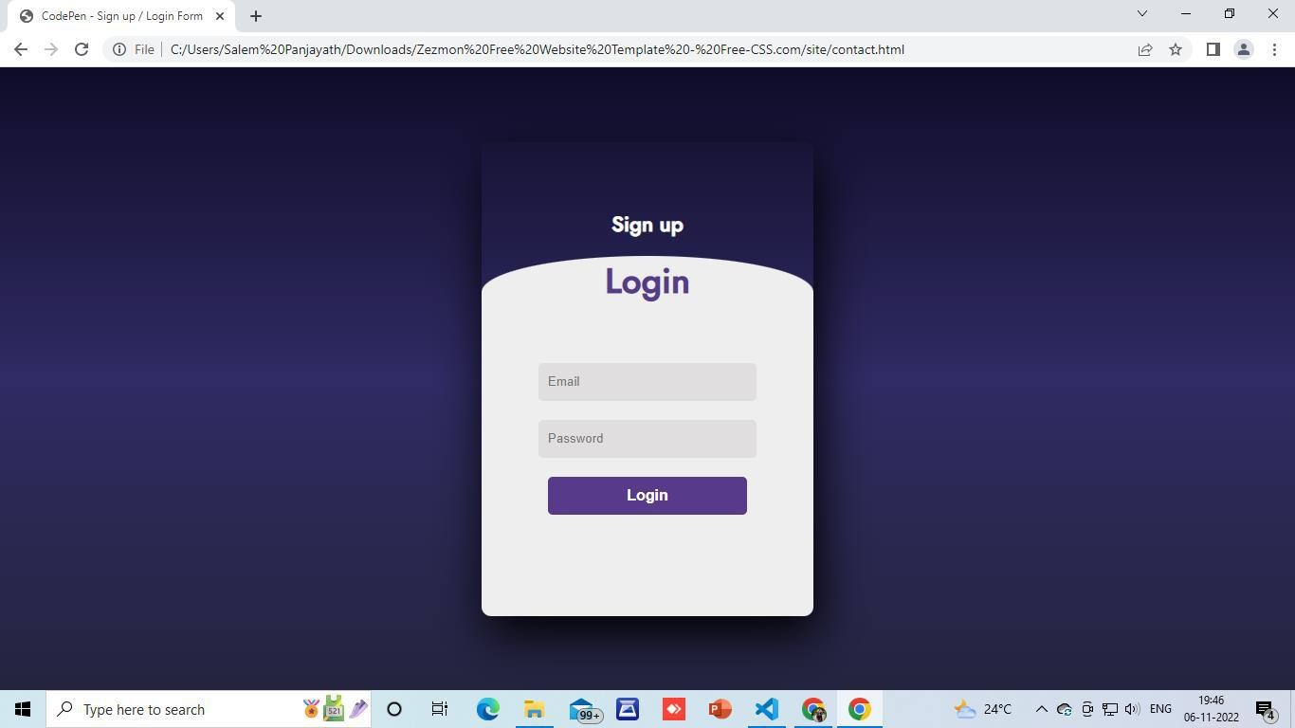

Signup page

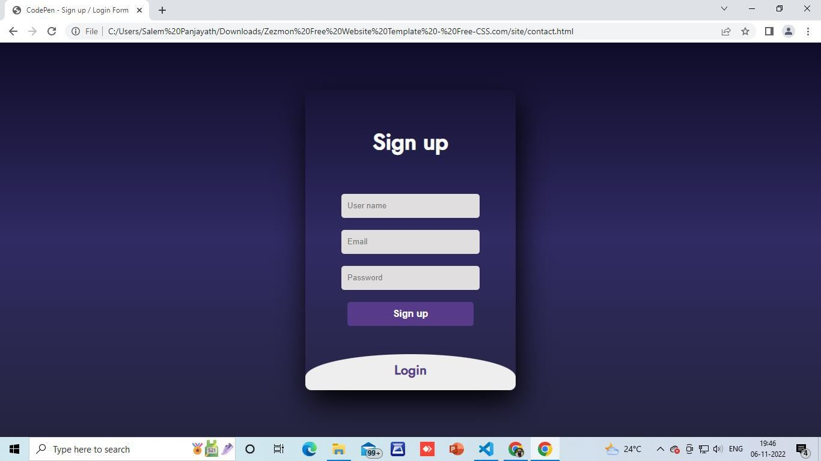

Product page

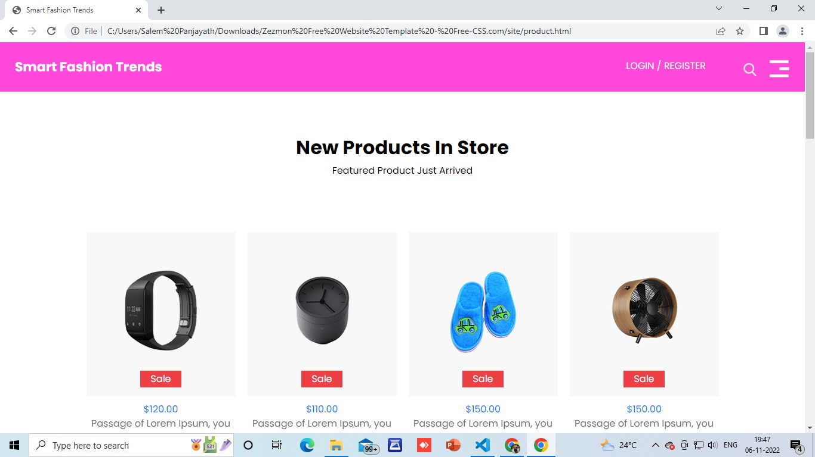

Home page

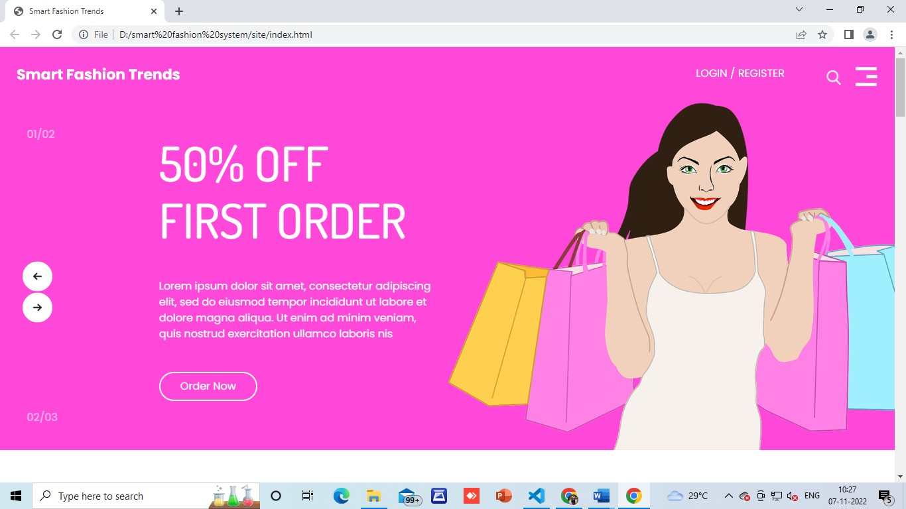

Database connection

